Transparency in Price & Service

Applying for the Grant – Collecting & distributing the assets
We anticipate this will take between 10 and 12 hours at £115 to £195 per hour, depending on the grade of fee earner. Total costs estimated at £2,340 + VAT and disbursements.
The exact costs will depend on the individual circumstances of the matter. For example, if there is one beneficiary and no property, costs will be at the lower end of the range. If there are multiple beneficiaries, a property and multiple bank accounts, costs will be at the higher end.
We will handle the full process for you.

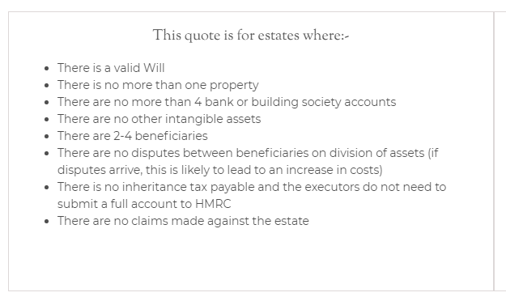
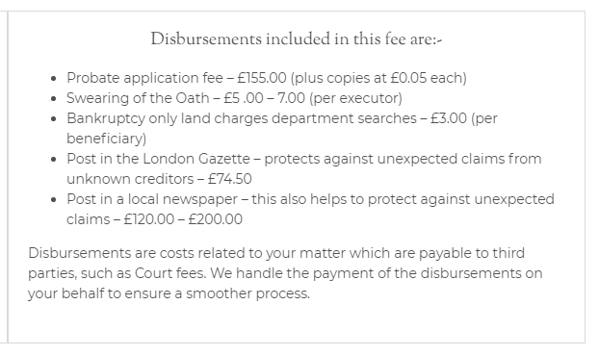

Potential additional costs
If there is no Will (meaning to die intestate), or the estate consists of any shareholdings (stocks and bonds) there are likely to be additional costs that could range significantly depending on the estate and how it is to be dealt with. We can give you a more accurate quote once we have more information.
If any additional copies of the Grant are required, they will cost £0.05 each (one per asset usually).
Dealing with the sale or transfer of any property in the estate is not included.

How long will this take?
On average, estates that fall within this range are dealt with within 12 – 18 months. However, intestacy cases can be more complex and they may take a number of years to conclude. This is due to the fact that government agencies may get involved (such as the DWP) and we may have to calculate and settle income, capital gains or inheritance tax.

Probate – Fixed fee
We can help you through the difficult process by obtaining the Grant of Probate on your behalf. We will also undertake the collecting and distributing of assets. We do offer a fixed fee if the likely value of the estate is less than £10,000.

